Sprint 2 Plan

Circular

Release 1.0

Completion Data: 2/1

Revision Number: 1

Scrum Master: Hengtian

**Sprint Goal**: To create a basic version of the website where we can see, create, and send offers on posts.

**Tasks**

*User Story 1: (5) As a user, I want a list view of items for barter so I can find out what’s available in Santa Cruz.* ***Must***

* Tasks
  + 1a Create a listings page (2)
  + 1b Set up database data structure (1)
    - Listings
      * ListingID(unsigned integer)
      * Item name (string)
      * User (string)
      * Image (img?)
      * Description of the item (string)
      * State (No Offers Made, At Least One Offer Made, Traded)
      * Requested trade item list
      * IsGiveaway (Boolean)
    - Users
      * Username
      * UserID
      * Listings
      * Whatever good sign in info is needed
  + 1c Fetch info from database to update listings (2)
  + 1d Create the user interface for viewing listings in material UI

*User Story 2: (5) As a person who doesn’t want to spend too much time on creating an account, I want to create my account with Google.* ***Must***

* Tasks
  + 2a Use google api for account creation (2)
  + 2b Store relevant user data in backend (2)
  + 2c create sign in and sign out buttons (1)

*User Story 3: (5) As someone who wants to give something away, I want to be able to create and post a listing so that other users can make offers.* ***Could***

* Tasks
  + 3a Create a page where users can fill out the information for the listing being posted, including images (3)
  + 3b Send post request to server and have it stored in the database (2)

*User Story 4: (8) As a user, I want to use a website with an intuitive and aesthetically pleasing design*

***Should***

* Tasks
  + 4a Plan out the user flows/storyboard (1)
  + 4b Sketch pages (1)
  + 4c Create a Prototype in Figma (2)
  + 4d Test Prototype (1)
  + 4e Generate React code from prototype (1)
  + 4f Connect react code to the app frontend (2)
  + 4g Create navigation bar in material UI

*User Story 5: (7) As someone interested in an item listed, I’d like to make an offer to exchange it for something I have.* ***Must***

* Tasks
  + 5a Modify the database to contain a table for offers, determine schema (1)
  + 5b Create a new form webpage were users can specify details of their offer, similar to 3a (2)
  + 5c Update the backend so that it receives offer requests from clients and updates the database with the new offer (2)
  + 5d Create a view to see all offers you have made as a user (1)
  + 5e Create a list view to see all offers for a particular listing (1)

**Team Roles**

* Ian (Product Owner, UI Designer)
* Kenneth (backend)
* Gonzalo (developer, full stack)
* Hengtian (Scrum Master, developer, frontend)
* Micheal (developer, backend)
* Daniel (developer)

**Initial Task Assignment**

* Ian: 4a-e
* Kenneth: 2a, 2b, 2c
* Gonzalo: 5c, 1c
* Hengtian: 3a, 3b
* Micheal: 1a, 1b
* Daniel: 5a, 5b

Infrastructure Tasks:

* Make a setup README

Spikes

* Google Account API
* Learn how to create and store data (chat history) into each user

**Initial burnup chart**

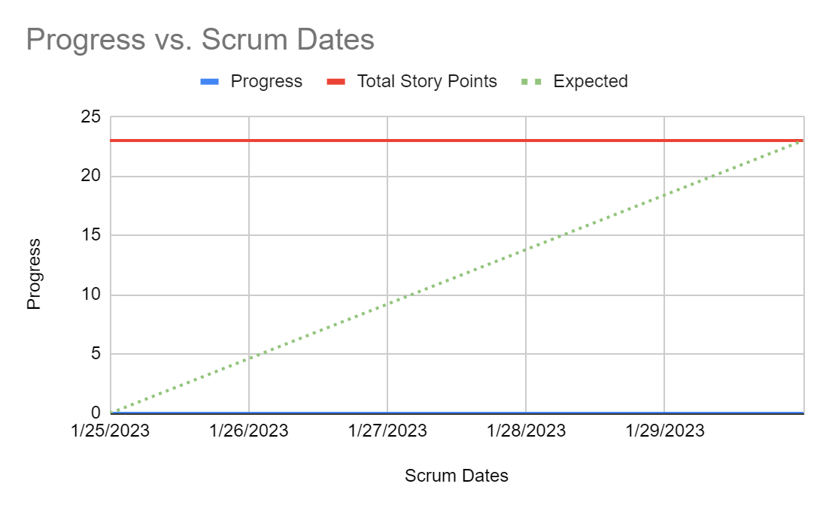

[**Initial Scrum Board**](https://trello.com/invite/b/gx6MgIyB/ATTI05a8695a17ffdbae9ebdfa6643b1ffb3EFEE51C2/tasks)

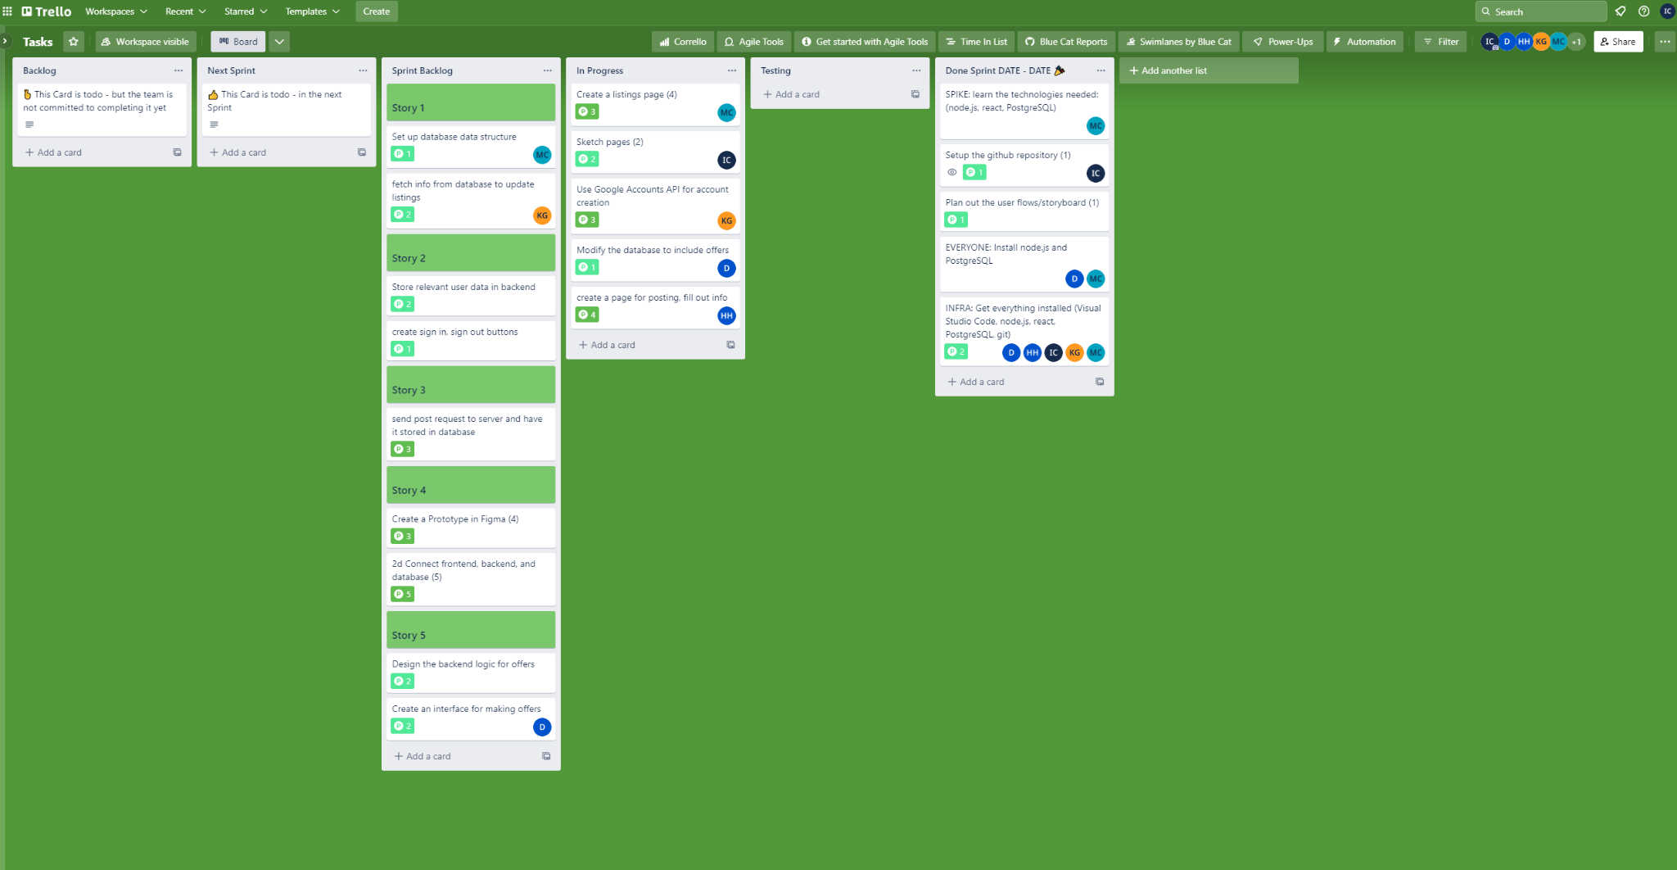

**Scrum Times:**

9:05 - 9:20 MWF